Delegate Information (all section must be completed)
Name
Job Title
Organisation
Address
Invoice Address (if different)

Telephone Number
Email Address

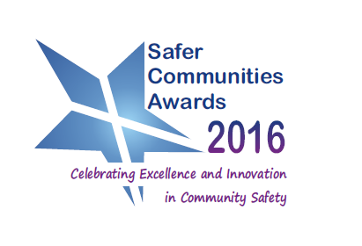 | Booking Form  Safer Communities Awards 5 September 2016  National Community Safety Convention 6 September 2016 | 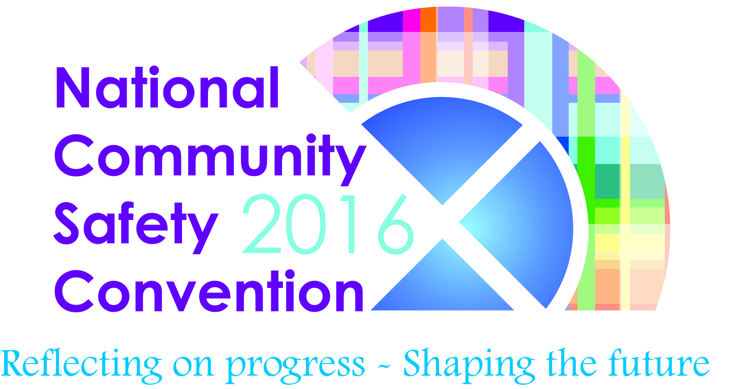

Please indicate which of the following you will be attending (Please note bookings does not include accommodation. Delegates are responsible for their own accommodation):

Annual Dinner and Awards Ceremony | 5 September 2016 | £60.00
National Community Safety Convention | 6 September 2016 | £60.00

Dietary requirements

Terms and Conditions – Cancellation Policy Payment will be required prior to attendance. An invoice will be issued as per delegate information above. SCSN will be operating a cancellation policy, as is our policy with all events. No refunds will be given to anyone cancelling after Friday 19 August 2016. Any delegate cancelling will be invoiced a cancellation fee. If you are unable to attend but have found someone to take your place, there will be no charge but SCSN must be informed or you will be invoiced as a non-attender. By completing this form you are accepting the terms and conditions of our cancellation policy.

Workshop Bookings Delegates will have the opportunity to attend two workshops on the day. Please indicate which two workshops you would like to attend. Workshops spaces are limited. In the event that your workshop is full, a member of SCSN staff team will contact you to select an alternative. It is our intention, depending on demand, to run each workshop twice.

Annual Dinner and Safer Communities Award Ceremony – 5 September 2016
Grand Central Hotel, Glasgow
Door open 18:45, dinner will be served 19:30. Dress Code – smart

National Community Safety Convention – 6 September 2016
Grand Central Hotel, Glasgow
Doors open 08:45, event will start at 09:30

Please return your booking form to denise.huntridge@scsn.org.uk.

Please select 2 workshops from the list below:
Workshop Themes | Option
Community Empowerment
Scottish Community Development Centre

This workshop will introduce the Community Empowerment Act and the revised Standards for Community Engagement. We will discuss the implications of the Act’s ‘Participation Request’ and the revised Standards for Community Engagement for community safety practitioners. Both of these frameworks will go some way to realising the Scottish Governments ambition of allowing communities to be more involved in decision making and will have implications for practice.

Unintentional Injuries
Scottish Fire and Rescue Service

Presenting the evidence base and strategic priorities to shape the future direction of BSCP Phase 2 which aims to reduce unintentional physical and psychological harm that could be predicted and/or prevented.

Evidencing Impact
Scottish Community Safety Network

Introducing SCSN new toolkit to support evidencing impact through continuous programme evaluation. This workshop will look how we ‘tell the story’ and evidence the impact of projects and interventions using qualitative and quantitative data to evidence progress and shape future initiatives.

Equally Safe Strategy-Draft Action Plan
COSLA

A logic modelling workshop to inform the content and delivery of the Capacity and Capability work stream draft action plan aimed at ‘non-specialist’ mainstream services, which aims to support employers/officers to identify and respond to employees and service users needs.

The Journey Back to Citizenship
Positive Prisons? Positive Futures

An interactive session involving people with convictions, a stage set prison cell, an inflatable elephant and others. How can the barriers that obstruct someone’s journey back from punishment to citizenship be recognised, reduced and removed? Using the Forum Theatre method we will seek to involve the audience in achieving positive outcomes to the situations we present.

